JSON Refiner Advanced Edition
Professional JSON Processing Tool with Gardio Interface
Team members:
S.Naveen veera perumal,
B.Hari Prasath,
K.Kalaiagathiyan,
V.Kamaleshwaran,
G.Abdul hader.

Course: B.sc. Information Technology.
College: Syed Ammal Arts and Science College.
Year:2023-2026
Topic: JSON Refiner Advanced Edition (Professional JSON Processing Tool with Gardio Interface).

Coding:

# JSON Refiner Advanced Edition
# Author: Project Implementation
# Python 3.8+

import gradio as gr
import json
import re
from enum import Enum
from datetime import datetime
from typing import Dict, Any
from jsonschema import validate, ValidationError

# ============================================
# ENUM FOR CASE STYLE
# ============================================

class CaseStyle(Enum):
SNAKE_CASE = "snake_case"
CAMEL_CASE = "camelCase"
KEBAB_CASE = "kebab-case"
PASCAL_CASE = "PascalCase"

# ============================================
# CORE JSON ENGINE
# ============================================

class JSONRefiner:

def __init__(self):
self.history = []

# ----------------------------
# TYPE INFERENCE
# ----------------------------

def infer_type(self, value: str):

value = value.strip()

if value.lower() in ["true", "yes", "on"]:
return True

if value.lower() in ["false", "no", "off"]:
return False

if value.lower() in ["null", "none", "nil", "n/a"]:
return None

try:
return int(value)
except:
pass

try:
return float(value)
except:
pass

try:
return json.loads(value)
except:
pass

return value

# ----------------------------
# CASE CONVERSION
# ----------------------------

def snake_case(self, text):

text = re.sub(r'[\s\-]+', '_', text)
text = re.sub(r'([a-z])([A-Z])', r'\1_\2', text)
return text.lower()

def camel_case(self, text):

words = self.snake_case(text).split("_")
return words[0] + "".join(w.title() for w in words[1:])

def kebab_case(self, text):

return self.snake_case(text).replace("_", "-")

def pascal_case(self, text):

words = self.snake_case(text).split("_")
return "".join(w.title() for w in words)

def normalize_key(self, key, style: CaseStyle):

if style == CaseStyle.SNAKE_CASE:
return self.snake_case(key)

if style == CaseStyle.CAMEL_CASE:
return self.camel_case(key)

if style == CaseStyle.KEBAB_CASE:
return self.kebab_case(key)

if style == CaseStyle.PASCAL_CASE:
return self.pascal_case(key)

return key

# ----------------------------
# PARSER
# ----------------------------

def parse_text(self, text, style):

result = {}

for line in text.split("\n"):

if ":" not in line:
continue

key, value = line.split(":", 1)

key = self.normalize_key(key.strip(), style)
value = self.infer_type(value)

result[key] = value

return result

# ----------------------------
# FLATTEN JSON
# ----------------------------

def flatten(self, data, parent="", sep="."):

items = {}

for k, v in data.items():

new_key = f"{parent}{sep}{k}" if parent else k

if isinstance(v, dict):
items.update(self.flatten(v, new_key))

else:
items[new_key] = v

return items

# ----------------------------
# UNFLATTEN JSON
# ----------------------------

def unflatten(self, data, sep="."):

result = {}

for key, value in data.items():

parts = key.split(sep)

current = result

for p in parts[:-1]:

if p not in current:
current[p] = {}

current = current[p]

current[parts[-1]] = value

return result

# ----------------------------
# MERGE JSON
# ----------------------------

def merge(self, *objects):

result = {}

for obj in objects:
result.update(obj)

return result

# ----------------------------
# STATS
# ----------------------------

def stats(self, data):

return {
"keys": len(data),
"types": list(set(type(v).__name__ for v in data.values())),
}

engine = JSONRefiner()

# ============================================
# FUNCTIONS FOR UI
# ============================================

def refine(text, style):

style = CaseStyle(style)

data = engine.parse_text(text, style)

output = json.dumps(data, indent=2)

engine.history.append(
{
"time": str(datetime.now()),
"input": text,
"output": output
}
)

stats = engine.stats(data)

stat_text = f"""
Keys: {stats["keys"]}
Types: {stats["types"]}
"""

return output, stat_text

def flatten_json(data):

try:

data = json.loads(data)

result = engine.flatten(data)

return json.dumps(result, indent=2)

except Exception as e:

return str(e)

def unflatten_json(data):

try:

data = json.loads(data)

result = engine.unflatten(data)

return json.dumps(result, indent=2)

except Exception as e:

return str(e)

def merge_json(j1, j2):

try:

d1 = json.loads(j1)
d2 = json.loads(j2)

result = engine.merge(d1, d2)

return json.dumps(result, indent=2)

except Exception as e:

return str(e)

def validate_json(data, schema):

try:

data = json.loads(data)
schema = json.loads(schema)

validate(data, schema)

return "✅ Valid JSON"

except ValidationError as e:

return f"❌ {e.message}"

except Exception as e:

return str(e)

# ============================================
# GRADIO UI
# ============================================

with gr.Blocks(title="JSON Refiner Advanced") as app:

gr.Markdown("# JSON Refiner Advanced Edition")

with gr.Tab("Refine"):

text = gr.Textbox(lines=10, label="Key Value Input")

style = gr.Radio(
["snake_case", "camelCase", "kebab-case", "PascalCase"],
value="snake_case"
)

btn = gr.Button("Refine")

output = gr.Code(language="json")

stats = gr.Textbox()

btn.click(refine, [text, style], [output, stats])

with gr.Tab("Flatten"):

inp = gr.Code(language="json")

btn = gr.Button("Flatten")

out = gr.Code(language="json")

btn.click(flatten_json, inp, out)

with gr.Tab("Unflatten"):

inp = gr.Code(language="json")

btn = gr.Button("Unflatten")

out = gr.Code(language="json")

btn.click(unflatten_json, inp, out)

with gr.Tab("Merge"):

j1 = gr.Code(language="json")
j2 = gr.Code(language="json")

btn = gr.Button("Merge")

out = gr.Code(language="json")

btn.click(merge_json, [j1, j2], out)

with gr.Tab("Validation"):

data = gr.Code(language="json")
schema = gr.Code(language="json")

btn = gr.Button("Validate")

result = gr.Textbox()

btn.click(validate_json, [data, schema], result)

app.launch()
Output:

It looks like you are running Gradio on a hosted Jupyter notebook, which requires `share=True`. Automatically setting `share=True` (you can turn this off by setting `share=False` in `launch()` explicitly).

Colab notebook detected. To show errors in colab notebook, set debug=True in launch()
* Running on public URL: https://a2c23b878397c9485b.gradio.live

This share link expires in 1 week. For free permanent hosting and GPU upgrades, run `gradio deploy` from the terminal in the working directory to deploy to Hugging Face Spaces (https://huggingface.co/spaces)

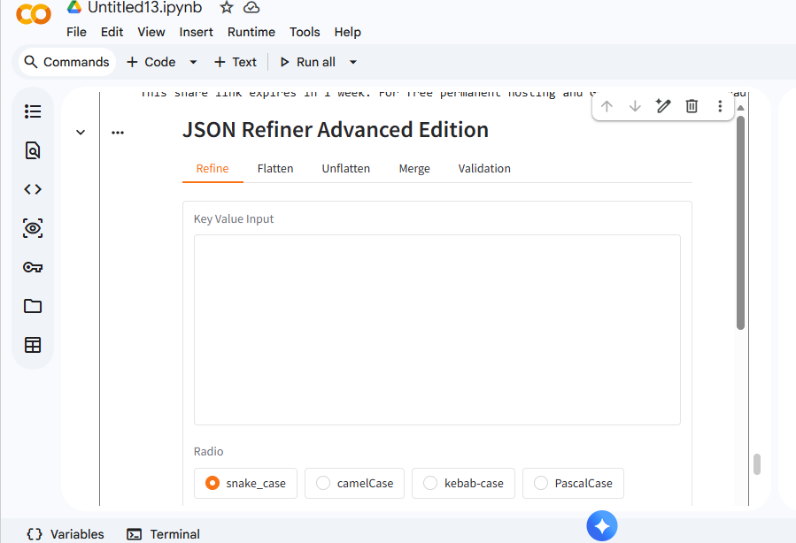

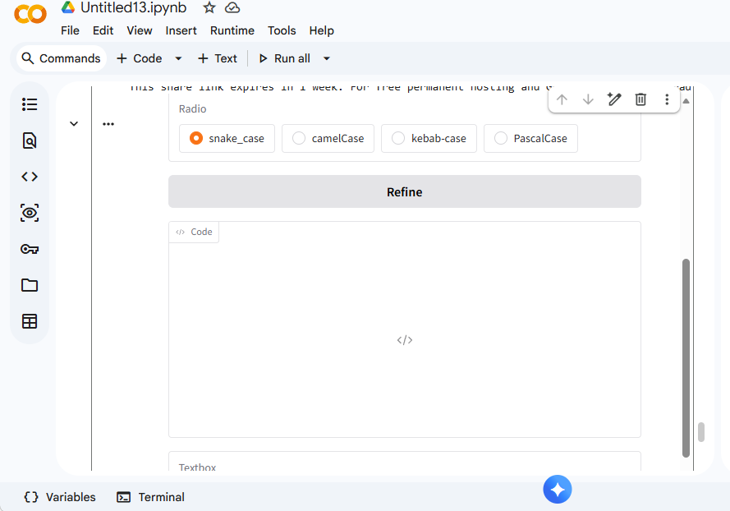

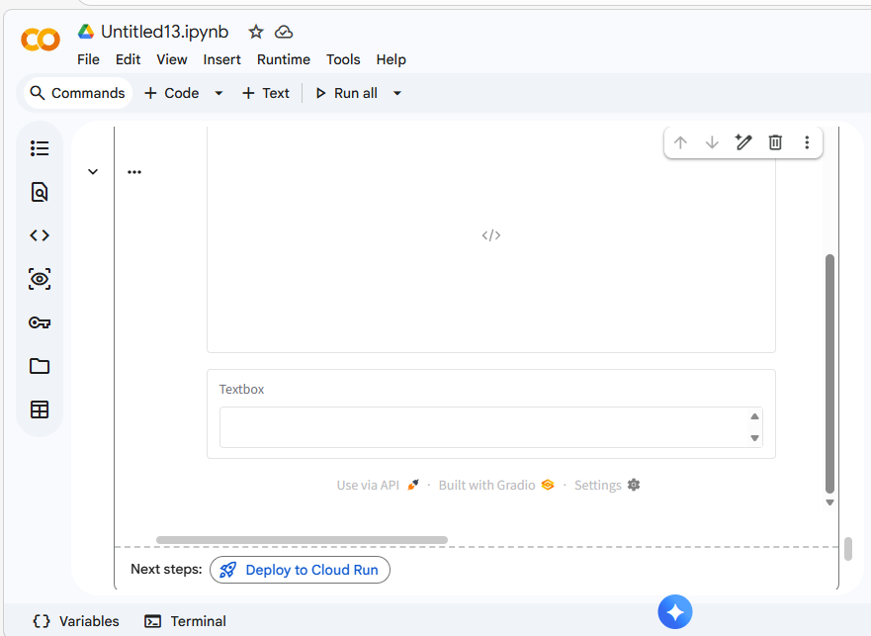

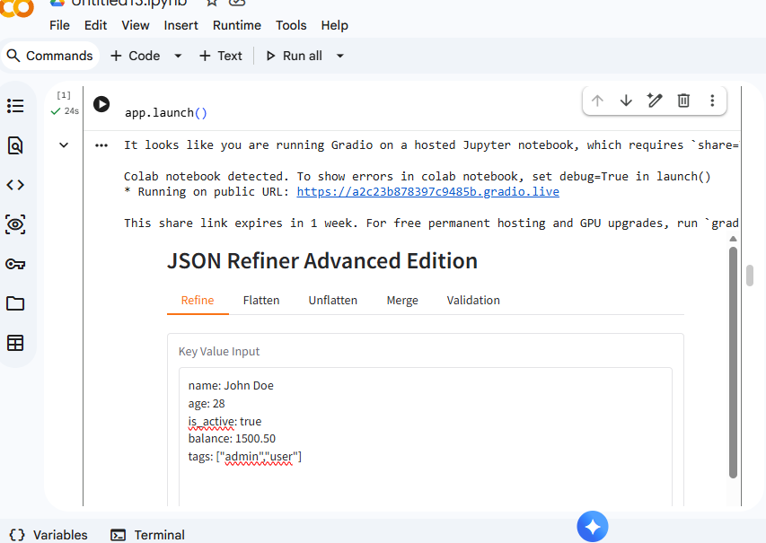
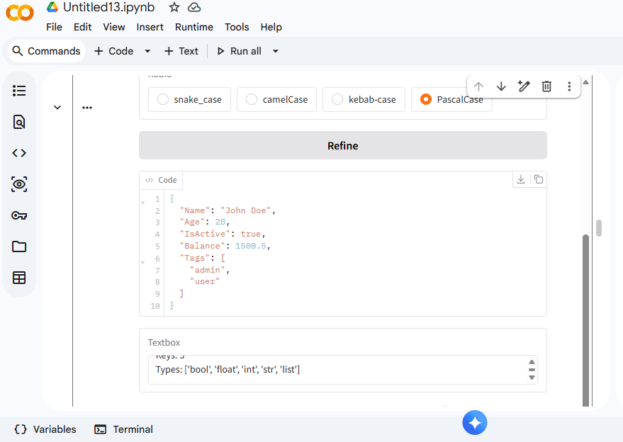
Result:
Thus the above program has been executed successfully.

